**LV connections b/w HV batteries and s-box Connector checks**

These connectors can wiggle more than they should if the white secondary locks are not fully pushed in, so it’s likely that is the issue. Worth a test drive to verify.

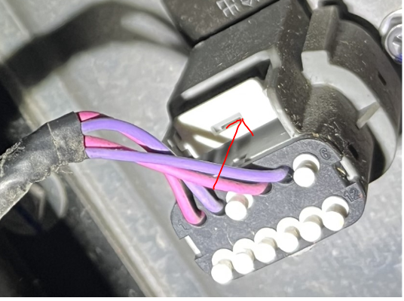

Before replacement, it’s recommended to perform a check to see if the fault is intermittent:

check to look at how the harnesses are secured at the crossovers between ESS assemblies (at the rear of the structures) We have seen some in the field that had zip ties that are way too tight and can cause damage long term.   
A shake test with key on will reproduce the fault if this is an issue.

Generally, there will be BMS age counts or other faults from the BMS if the LV supply is interrupted to the S-box. This fault is isolated to communication between the CSC boards in the packs and the S-box.